Software Requirements Engineering – Lab Report
Sources of Requirements + Kano Model — University Course Registration System
Group: Hudaibia, Sarah Arif, Eshaal Nazir, Abdul Samad
Submitted to: Sir Fahim Muhammad Khan Date: 24 Sept 2026

1. What we did
For this lab we had to find out where the requirements for a new university course registration system should come from and then use the Kano Model to check how students feel about some possible features of it. We picked 8 sources, listed 10 candidate features, made a Kano questionnaire out of them, sent it out, and got 40 responses back. Below is everything we found.

2. Sources of requirements (8)
Source | Example | What we get from it
Students | The people who will actually use the system | What they need, what annoys them now
Registrar office | Registration staff | Rules, approvals, policies
Faculty | Course instructors | Prerequisites, seat limits
IT staff | University IT department | Security, servers, technical limits
Current system | The old manual process | What already works, what doesn't
Academic policies | University rules and deadlines | What the system must follow
Watching students register | Observing registration week | Real problems people run into
Survey | Our Kano questionnaire | What students actually want most

3. Candidate features (10)
These are the 10 features we picked, based on the sources above, and later put into our survey.
No. | Feature
1 | Search courses by code/title/department
2 | Show remaining seats
3 | Registration confirmation
4 | SMS/email notification
5 | Automatic course recommendations
6 | Dark mode
7 | Download timetable as PDF
8 | Remember selected courses
9 | Save data if network drops
10 | Fast response at peak times

4. The Kano questionnaire
For each of the 10 features above we made two questions, one asking how the student would feel if the feature WAS there, and one asking how they'd feel if it was NOT there. Both used the same 5 answers: I like it / I expect it / I am neutral / I can tolerate it / I dislike it. Here are the actual question pairs we used:
Feature | Functional question | Dysfunctional question
Course search | How would you feel if you could search courses by code/title/dept? | How would you feel if you could NOT search courses this way?
Seat display | How would you feel if the system showed remaining seats? | How would you feel if it did NOT show remaining seats?
Registration confirmation | How would you feel if you got a confirmation after registering? | How would you feel if you did NOT get any confirmation?
SMS/email notification | How would you feel if you got SMS/email updates about registration? | How would you feel if you did NOT get any such updates?
Course recommendations | How would you feel if the system recommended courses to you? | How would you feel if it did NOT recommend anything?
Dark mode | How would you feel if the system had a dark mode option? | How would you feel if it did NOT have dark mode?
Download timetable | How would you feel if you could download your timetable as PDF? | How would you feel if you could NOT download it?
Remember courses | How would you feel if it remembered your picks before you submit? | How would you feel if it did NOT remember your picks?
Data preservation | How would you feel if your data was safe during a network drop? | How would you feel if your data was lost during a network drop?
Fast peak response | How would you feel if the system stayed fast during rush hours? | How would you feel if it got slow during rush hours?
We built this as a Google Form titled "Kano Analysis — University Course Registration System", tested it ourselves first, then sent it out to students.
Form link: https://docs.google.com/forms/d/e/1FAIpQLSf-5ZQl_5JUhBtiqAMdy_f3jSNCsk0-UHsZsZPPcJL35pUbOw/viewform

5. How we classified answers
We used the standard Kano table below to turn each pair of answers into one letter (A/O/M/I/R/Q). This was done in a spreadsheet, not by hand, for all 40 responses. Our raw responses and the full classification of every single answer are in a separate Excel file (Kano_Analysis_Full.xlsx) attached along with this report.
Have it \ Don't have it | Like | Expect | Neutral | Tolerate | Dislike
Like | Q | A | A | A | O
Expect | R | I | I | I | M
Neutral | R | I | I | I | M
Tolerate | R | I | I | I | M
Dislike | R | R | R | R | Q

6. Results (n = 40)
A few people skipped a question or two here and there, so those specific answers were left out and not counted for that one feature.
Feature | A | O | M | I | R | Q | Dominant
Course search | 15 | 11 | 1 | 8 | 0 | 4 | Attractive
Seat display | 12 | 9 | 4 | 9 | 0 | 4 | Attractive
Registration confirmation | 5 | 12 | 5 | 10 | 2 | 4 | One-dimensional
SMS/email notification | 9 | 9 | 2 | 13 | 1 | 4 | Indifferent
Course recommendations | 8 | 8 | 1 | 12 | 3 | 4 | Indifferent
Dark mode | 6 | 8 | 1 | 13 | 5 | 6 | Indifferent
Download timetable | 8 | 11 | 5 | 7 | 1 | 6 | One-dimensional
Remember courses | 9 | 8 | 3 | 10 | 3 | 4 | Indifferent
Data preservation | 5 | 8 | 3 | 10 | 3 | 8 | Indifferent
Fast peak response | 7 | 12 | 5 | 9 | 1 | 5 | One-dimensional
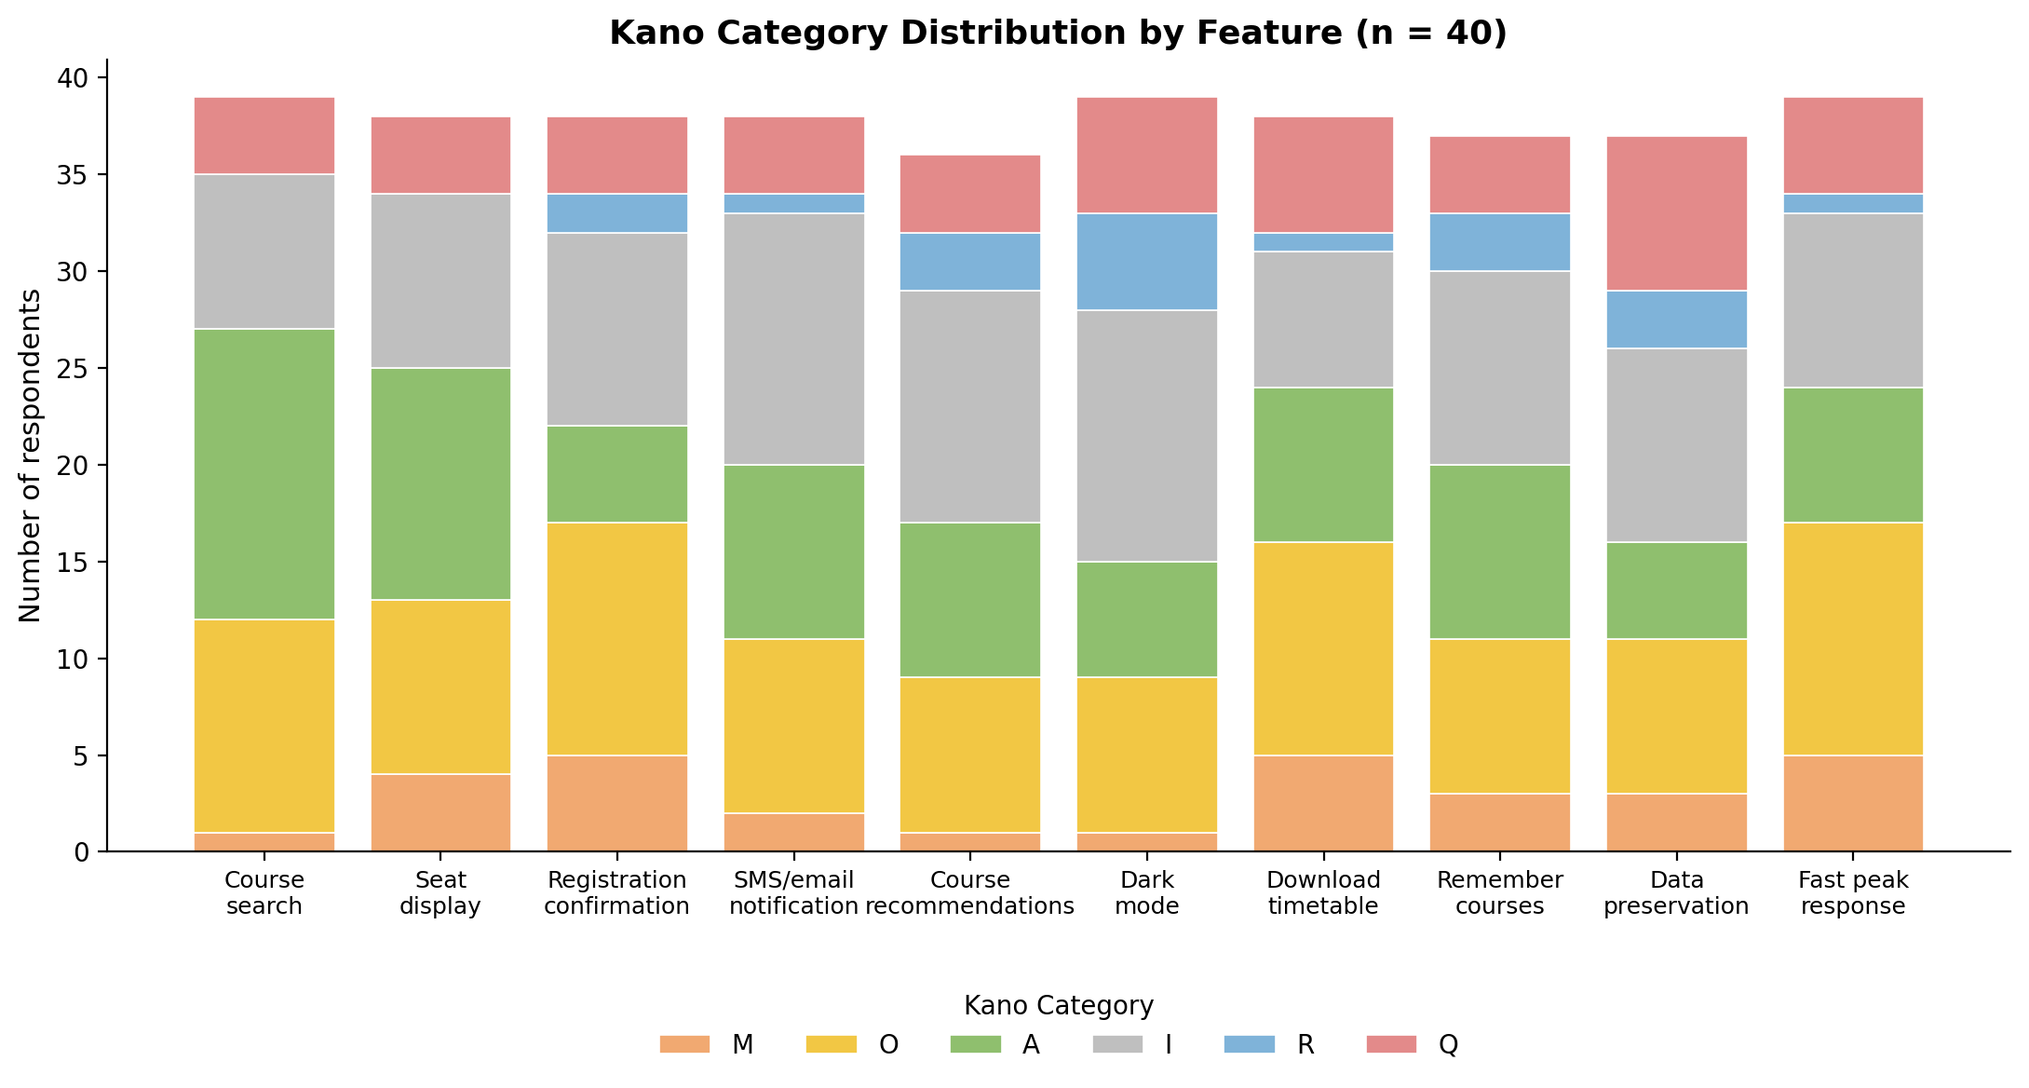

7. What the results mean
Course search and the seat display came out as Attractive, students like having them but won't get too mad if they're basic, though for this system we'd still build both early since the whole app is built around them. Registration confirmation, downloading the timetable, and fast response at busy times all came out One-dimensional, so the better we do these, the happier students are, and the worse we do them, the more they complain. Everything else, notifications, recommendations, dark mode, remembering courses, saving data during network issues, came out mostly Indifferent, students don't care much either way.
Questionable example: "Save data if network drops" had the most Questionable answers (8 out of 40). We think it's because the question describes a specific situation and not everyone imagined the same thing when answering both parts, so their answers ended up contradicting each other.
Indifferent example: Dark mode had the most Indifferent answers (13 out of 40). Makes sense, it's just a look/theme thing and has nothing to do with actually registering for a class, so most people don't really care if it's there or not.

8. Does this decide what we build first?
Not on its own. Kano only tells us how students feel about a feature, it doesn't tell us how much time, money, or effort that feature needs, and it doesn't account for things like server limits or approval processes that the registrar or IT team have to deal with. So even though course search came out "just" Attractive, we'd still build it early since the whole system depends on it. Registration confirmation and fast response at peak times came out One-dimensional, so these need to be done well since students will notice immediately if they're slow or broken. Something like dark mode being Indifferent means it's fine to leave for later, or drop it completely if the team is short on time, since it won't really change how satisfied students are either way. Basically, Kano tells us how people feel, but we still need to think about cost and effort before deciding what actually gets built first.

9. Who did what
Name | Worked on
Hudaibia | Requirement sources + feature list
Sarah Arif | Questionnaire + Google Form
Eshaal Nazir | Spreadsheet + classification + chart
Abdul Samad | Write-up + reflection + final report

